Sisters of Saint Joseph of Cluny

Special Interest Articles:

- Anne Marie Javouhey
- Superior General.
Sister Claire Houareau,
- Letter from Sierra Leone

Newsletter Date

Volume 1, Issue 1
Province of Ireland & Great Britain/ +353 1 8213134
Anne Marie Javouhey 1779 - 1851
Founder of the Sisters of St. Joseph of Cluny 1807
Beatified 15th October 1950.
Feastday 15th July
A very pretty young woman flits through the streets in the dark of night during the reign of the French Revolution. No one is supposed to be abroad at that hour and real dangers lurk at every corner but, while she is cautious, this young woman obviously has a particular destination in mind and is determined that nothing will deflect her from her purpose. She is searching out a priest to bring him to someone who needs him - an act that could be fatal for her, and the priest, should the soldiers get wind of it.

Anne-Marie Javouhey, Foundress of the Sisters of St. Joseph of Cluny, thus displayed at an early age her courage and her zeal for the spreading of the knowledge and love of Christ. And these were just a couple of the virtues that were to characterise the rest of her life. At the end of a night fraught with danger but with her task successfully accomplished, Anne-Marie could laugh and joke when she reached back home in an attempt to relieve the tension and worry that her parents experienced each time they saw their daughter disappear into the night. Joy was to be her companion in life. So she would express, in later years, her loneliness at times, her sadness at experiences and events but she could still say "I am sad at times but never unhappy". She became a Religious, a Missionary, an adviser and confidante of governments and colonists.

Hers was a happy family home with parents, and especially a Father who doted on her. She was their pride and joy - and with good reason, since she was good-looking, clever, talented and a good leader. Blessed by nature, she was also blessed by grace and at an early age the Lord touched her heart in an extraordinary way. So while her indulgent and loving Father was still looking around for a good husband for his beautiful daughter, that daughter had already given herself to God with promises to do His Will. - The ‘Holy Will of God' was the steady focal point of her compass and has remained the central point of the Cluny charism to this day. Two stubborn people - Anne-Marie and her Father, were locked in combat, a situation that was to last for quite some time until Monsieur Javouhey gave in, and not only gave in but gave his support, wholeheartedly, financially and emotionally, to Anne-Marie's plans.

After several abortive attempts at following Christ in established Religious Communities, the Lord let Anne-Marie know that He had other plans for her and eventually on 12/5/1807 the first group of young women (Anne-Marie, her 3 sisters and 5 friends) made their vows in the newly founded Congregation of St. Joseph - "Cluny" was only added in 1812 when a large house in Cluny, France, was bought by Anne-Marie's Father and became at that point the principal house of the new Congregation.

Hers was a life-time of teaching, nursing, caring for the mentally ill and leprosy patients, taking on the tasks of governments to build up in their colonies a people who would be good, solid citizens, preparing slaves for freedom. It was a life of joys and sorrows ,of successes and failures, of recognition and rejection, of pain and humiliation heaped on her by church leaders and all accepted with the same equanimity,. Such was the life of Anne-Marie until her death in 1851. Such has been the life of countless Cluny Sisters during the past 200 years. Anne-Marie said "we must try to accommodate ourselves to the times to gain it to the good God"....a daunting but not impossible task for those who believe that "the future of humanity lies in the hands of those who are strong enough to provide coming generations with reasons for living and hoping" (Vatican II - the Church Today:31)

Anne Marie Javouhey

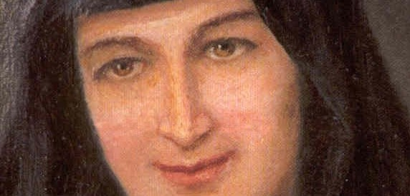




“Gallen Priory was initially our Novitiate,” Provincial Sister Rowena Galvin explained. “It opened 91 years ago, and during that time 1,032 Sisters were professed. They went to all parts of the world, and as a result we’ve got some great schools, hospitals, dispensaries and advocacy groups, and pastoral work of all kinds.
“It all began here in Ferbane,” she added, “and that’s what we were remembering and thanking God for.”

- See more at: http://www.offalyindependent.ie/

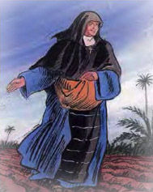

Hers was a happy family home with parents, and especially a Father who doted on her. She was their pride and joy - and with good reason, since she was good-looking, clever, talented and a good leader. Blessed by nature, she was also blessed by grace and at an early age the Lord touched her heart in an extraordinary way. So while her indulgent and loving Father was still looking around for a good husband for his beautiful daughter, that daughter had already given herself to God with promises to do His Will. - The ‘Holy Will of God' was the steady focal point of her compass and has remained the central point of the Cluny charism to this day. Two stubborn people - Anne-Marie and her Father, were locked in combat, a situation that was to last for quite some time until Monsieur Javouhey gave in, and not only gave in but gave his support, wholeheartedly, financially and emotionally, to Anne-Marie's plans.

After several abortive attempts at following Christ in established Religious Communities, the Lord let Anne-Marie know that He had other plans for her and eventually on 12/5/1807 the first group of young women (Anne-Marie, her 3 sisters and 5 friends) made their vows in the newly founded Congregation of St. Joseph - "Cluny" was only added in 1812 when a large house in Cluny, France, was bought by Anne-Marie's Father and became at that point the principal house of the new Congregation.

Hers was a life-time of teaching, nursing, caring for the mentally ill and leprosy patients, taking on the tasks of governments to build up in their colonies a people who would be good, solid citizens, preparing slaves for freedom. It was a life of joys and sorrows ,of successes and failures, of recognition and rejection, of pain and humiliation heaped on her by church leaders and all accepted with the same equanimity,. Such was the life of Anne-Marie until her death in 1851. Such has been the life of countless Cluny Sisters during the past 200 years. Anne-Marie said "we must try to accommodate ourselves to the times to gain it to the good God"....a daunting but not impossible task for those who believe that "the future of humanity lies in the hands of those who are strong enough to provide coming generations with reasons for living and hoping" (Vatican II - the Church Today:31)

This article was made possible in part through the assistance of Vocations Ireland
Sisters of Saint Joseph of Cluny
Page 2 of 4

Anne Marie Javouhey continued

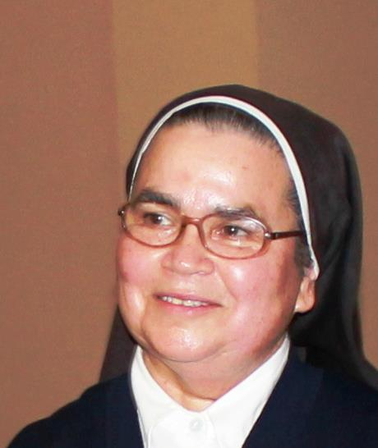
Letter from Sierra Leone

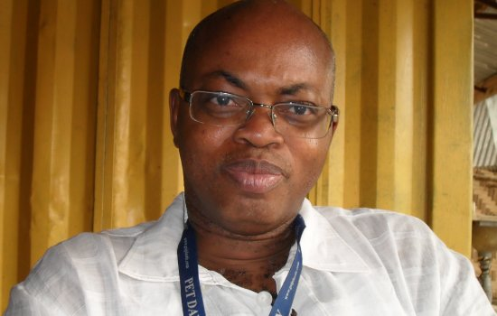
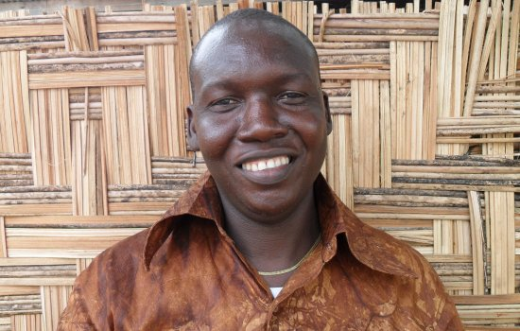
John Kalawa, the softspoken grandson of a Limba king, tells me, “I will come to collect you at 5:00.” “Fine,” I say. I don’t know where we’re going; I know only that it will be an adventure. In Makeni, Sierra Leone, everything is an adventure.As I get on the back of his motorbike, Kalawa tells me of a group of blind beggars he has formed into an association. We are going to meet them in their camp.
The blind are considered a scourge here. Few have jobs, and many beg from people who are poor themselves. The blind live in squalor and rely on their children to lead them around by the shoulder. The children of the blind are also treated as pariahs by the rest of society; they are thought to be filthy, ill-mannered, and uneducable. John Kalawa is shepherd to the blind. During Sierra Leone’s civil war (1991–2001), he worked at a parish house. One day the priest there told the rest of the staff that he was taking them with him on a pastoral visit, and left Kalawa in charge of the house. They never returned. One day a knock came at the door. Many of the blind in the neighborhood had come looking for a meal. So Kalawa fed them. They returned the following afternoon for their meal, but the food was gone. “Come back tomorrow,” Kalawa told them.The next day came and went without any supplies and all he could say was, “Come back tomorrow.” Later, members of the rebel army knocked at the door and demanded a meal. “The blind people ate all the food some time ago and they will be coming back later for their lunch,” Kalawa told them. “What can I do?”“Don’t worry,” the rebels said. They broke into a market for food, brought it back to the parish house, and helped Kalawa feed the blind when they came back. Ever since then, Kalawa has felt a special responsibility for those without sight. He formed a group called the Blind Beggars Association, which collects small dues each month from about sixty families in order to provide a little security for their children in case a parent gets sick or dies. The families squat on land that used to belong to a city-council member. Since his death his heirs have wanted to clear the people off and sell the land. Kalawa is searching for a new spot—one with enough space for a small workshop—but has no money for land. “All they want is a place for themselves to live in peace and so they can work together,” he says. “If these people are able to get recognized as having their own place, the community will see they have dignity.” We arrive at the camp, where I am introduced to the chairman of the Blind Beggars. He formally welcomes me to the group, and several of the others members give short speeches. They all welcome and bless me. Then the children surround me and lead me in a parade into the camp, a small gathering of huts and stick houses. “Look at this tarpaulin,” Kalawa tells me. “We put it on this roof to cover a big hole.” Here “a patch on poverty” is not just a metaphor; it’s a tarp on the roof of a stick house on land about to be sold out from under its inhabitants. I ask John how these people will survive the rainy season. “By the power of God,” he answers

Fr. Joseph Turay
John Kalawa

Dear Sisters, I am happy to join you on this first day of May, a day on which we also remember our Patron, St Joseph the worker We are very aware of all those competent, wholehearted and devoted people working everywhere. We also remember those who are overburdened. Nor do we forget the many who have no work and can no longer support themselves, their families, especially the children ….. There are so many intentions! This is also an opportunity to take another look at how we do our own work, that it may always be a "humble service" for our brothers and sisters according to the example of St Joseph, as Anne Marie Javouhey used to say. This morning we celebrated the dedication in the Mother House of our chapel (built in 1860). Many generations of Sisters have passed through it, prayed in it, made profession and celebrated jubilees…..We thought of you all. I am preparing to fly to Peru on May 7th next. I confide myself to your prayers and know I can count on each one of you. May our Blessed Lady unite us more and more in this beautiful month of May!

Page 3 of 4
Sisters of Saint Joseph of Cluny

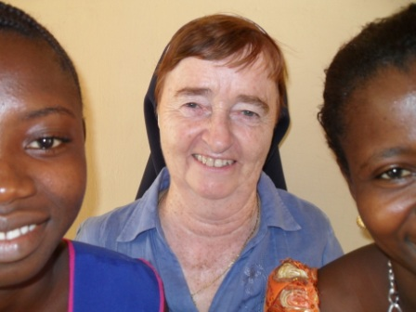

Sisters of Saint Joseph of Cluny
Province of ireland & Great Britain

PhONE:
+353 1 8213134

Fax:
+353 1 8224349

E-Mail:
cluny@sjc
Have but one heart and one soul

Back Page Story Headline

Among all the women religious in Makeni, Sr. Mary Sweeney, a sister of St. Joseph of Cluny, has served the longest (thirty-eight years). She was the first person I met when I arrived. She came to pick me up at the airport—a dicey business—at three in the morning. Her family had owned an old inn in Donegal, Ireland, for generations. “Mary from Dungloe—that’s me.”
Sr. Mary is the head teacher at the St. Joseph’s School for the Hearing Impaired—among the grandest buildings in all of Makeni. The students here get a basic education, and many get room and board on the premises. They come from all over the country to be at a place where they are not considered cursed and worthless; often their own families have shunned them. St. Joseph’s is a haven of hope and life. Although it receives no government support, it still manages to offer its pupils a material security they can find nowhere else. Not surprisingly, the children seem very happy.
In addition to teaching at St. Joseph’s, the Cluny sisters run the Loreto clinic, a private hospital for the poor, and work in a girls’ secondary school next door to St. Joseph’s. They also take care of anyone who shows up at their door. One morning, as I walked down the drive to the convent, I met a woman with her little boy, Noel. She was very agitated and her son looked limp. I learned he had had a seizure, which is thought by many here to be a mark of possession by a devil. I escorted her to see Sr. Mary and let the boy rest in the shade of the palaver hut outside. As the woman’s tears began to flow, Sister placed her hand on the woman’s chest and calmed her.
This article was made possible in part through the assistance of the American bishops’ Solidarity Fund for Africa.

“We want to build a civilization of love here at the university,” he tells me. That’s a tall order in a country that has known so much violence and injustice, but Fr. Turay seems confident. After a short pause he adds, “We will do it.”

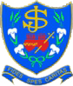
We’re on the Web!See us at:www.sjc.ie

Continued Story Headline

Province of Ireland

&

Great britain

